FIT5124 – Assignment 1 – Xiaohui Ding – 31291252
3 Security Analysis of Searchable Symmetric Encryption
3.1 Security Definition
Ans:
Given the security games:
Real_{Π}A(λ):
1. Adversary A(1^{k}) choose M, M.
2. Game runs (K, C, c) Matrix.Gen(1^{k}), Matrix.Enc(K, M, M), and gives (C, c) to A.
3. Then A requests again and again using client input in.
4. The game then runs the scheme with client input (K, in) and server input (C, c) and gives the transcript to A.
5. Eventually, A returns a bit for game to use as its own output.
Ideal_{Π}A, S (λ):
1. Adversary A(1^{k}) choose M, M.
2. Game runs (K’, C’, c’) Matrix.Gen(1^{L(k)}), Matrix.Enc(K’, L(C, c)) and gives (C’, c’) to A.
3. Then A requests again and again to run the Lookup operation using client input in.
4. The game gives the output of L(in) to Simulator, which outputs a simulated transcript that is given to A.
5. Eventually, A returns a bit for game to use as its own output.
Definition: Π is Leakage-secure against non-adaptive attacks if for all adversaries A there exists a simulator S such that:
$$Pr[Real_{Π}(λ) = 1] - Pr[Ideal_{Π}(λ) = 1] ≤ neg(λ)$$
3.2 Security Analysis
Ans:
1) Leakage function definition
- $L_{Setup: Gen\left(1^{k}\right), Enc\left(K, M, M\right)}=\left(C, c, λ_{1}, λ_{2}, n, \left|j\right|, \left|v\right|, \left|c\right|\right)$,
where:
$λ_{1},λ_{2}$ is the number of rows and columns of C,
n is the number of elements in c,
$\left|j\right|$ is the length of label $π\left(i\right) ⨁ F_{K_{1}}(α, β)$,
$\left|v\right|$ is the length of $v_{i} ⨁ F_{K_{1}}(α, β)$,
$\left|c\right|$ is the length of the element in c.
- $L_{Search: Lkp_{e}(γ,τ) }=\left(AP\left(τ\right), SP\left(τ\right)\right)$
  - $AP\left(τ\right)=\left(s, α^{'}, β^{'}\right), \left(j,v\right)$
where:
$\left(s, α^{'}, β^{'}\right)$ is the search token,
j is the permuted pointer $π(i)$ to $m_{i}$,
v is the semi-private data item related to m,
  - $SP\left(τ\right)=\left(s, α^{'}, β^{'}\right), l$
where:
l is from 1 to x,
x is the total number of queries.
2) How to simulate the security game
Given queries $\{τ_{1}, τ_{2}, …, τ_{x}\}$, the simulator S will generate a simulated matrix and vector from $L_{Setup: Gen\left(1^{k}\right), Enc\left(K, M, M\right)}$ and $L_{Search: Lkp_{e}(τ) }$.
S will create a $λ_{1}×λ_{2}$ matrix C’.
For each lookup token $τ$, S generates random keys $K_{1}'$, $K_{2}'$ with the same bit length of $K_{1},K_{2}$, and a random integer pair $\left(α^{''}, β^{''}\right)$ within the range $λ_{1}×λ_{2}$.
Then S computes the search token from $K_{1}'$, $K_{2}'$, $\left(α^{''}, β^{''}\right)$:
$s'≔F_{K_{1}'}\left(α^{''}, β^{''}\right)$,
$\left(α^{*}, β^{*}\right)≔P_{K_{2}'}(α^{''}, β^{''})$,
S also computes $\left(j^{'},v^{'}\right)≔\left(j,v\right)⨁{F_{K_{1}'}(α^{''}, β^{''}) }$and inserts $\left(j^{'},v^{'}\right)$ into $C^{'}[α^{*}, β^{*}]$.
For the rest location of $C'$, S generates random string pairs with the same bit length of $\left(j,v\right)⨁{s }$.
We also want to simulate a c’. But unluckily, we don’t know anything about m, which means we can’t simulate a c’ and use it with $\left(j,v\right)$ to get a same search result m.
In fact, in the scheme, the encryption and decryption of m are both on the client side, and this is why we can’t simulate the whole process.
3) How the simulated view is indistinguishable from the real view
- C & C’ are indistinguishable. They used the same PRF, PRP and symmetric encryption $Π$. They have same sizes, and each data item stored in both of the pairs have the same bit lengths.
- For each lookup query $q_{m}$, $K_{1}^{'},$ $K_{2}^{'}$ have the same length of $K_{1},$ $K_{2}$, and $\left(α^{''}, β^{''}\right)$ is within $λ_{1}×λ_{2}$ which means it is also indistinguishable from $(α, β)$.
- Thus, for each lookup query $q_{m}$, the simulated query $\left(s', α^{*}, β^{*}\right)$ is identical to $\left(s, α^{'}, β^{'}\right)$.
- The same $\left(j,v\right)$ with the help of the same PRF & PRP will be inserted into C’. Thus, the recovered $\left(j,v\right)$ from $C'[α^{*}, β^{*}]$ are also same with the recovered $\left(j,v\right)$ from $C[α^{'}, β^{'}]$. The search result is indistinguishable.
- For each lookup query $q_{m}$, after $\left(j,v\right)$ is recovered and returned to the client side, the client can use the same $j$ with his/her own $K_{3}$ to recover the same $m_{j}$. The final result is indistinguishable.
In conclusion, the simulator and the real-world case are indistinguishable.
Note: S firstly use $K_{1}^{'},$ $K_{2}^{'}, \left(α^{''}, β^{''}\right)$ to calculate $\left(s^{'},α^{*}, β^{*}\right)$ rather than directly use the leakage $\left(s, α^{'}, β^{'}\right)$ to simulate a $\left(s^{'},α^{*}, β^{*}\right)$ because we want to simulate the whole process as much as possible. If we don’t, there might be some residual leakage, for example, simulating time, from the simulating process.
I also want to add this comparison with our Tut 2 solution to demonstrate more clearly how the whole simulation process works:
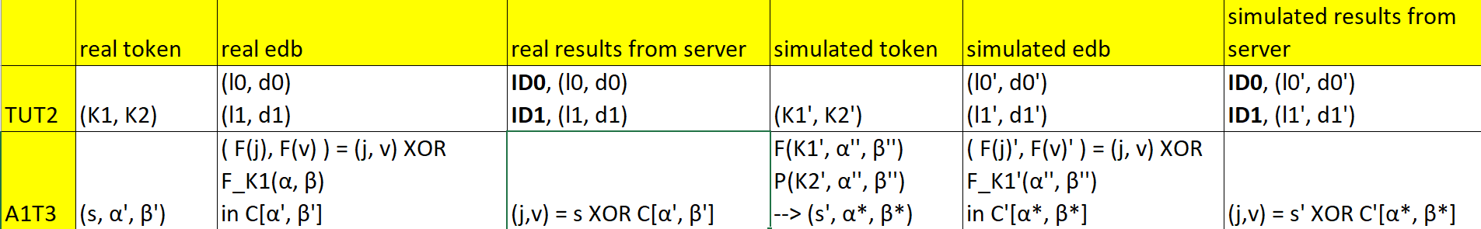
4 Count Attacks against Searchable Symmetric Encryption
4.1 Case study I
d1 = {w1, w2, w3, w4, w6} d2 = {w1, w2, w3, w6}
d3 = {w1, w2, w4, w6} d4 = {w1, w4, w6}
d5 = {w4, w5, w6} d6 = {w4, w6}
We can convert this into a table:
 | d1 | d2 | d3 | d4 | d5 | d6
w1 | 1 | 1 | 1 | 1
w2 | 1 | 1 | 1
w3 | 1 | 1
w4 | 1 |  | 1 | 1 | 1 | 1
w5 |  |  |  |  | 1
w6 | 1 | 1 | 1 | 1 | 1 | 1
We then generate the keyword co-occurrence matrix (presented as the table below):
 | w1 | w2 | w3 | w4 | w5 | w6
w1 | 4 | 3 | 2 | 3 | 0 | 4
w2 | 3 | 3 | 2 | 2 | 0 | 3
w3 | 2 | 2 | 2 | 1 | 0 | 2
w4 | 3 | 2 | 1 | 5 | 1 | 5
w5 | 0 | 0 | 0 | 1 | 1 | 1
w6 | 4 | 3 | 2 | 5 | 1 | 6
In general, we have to fill the rest of the table. But in this case, since the numbers in diagonal are all unique, we can simply deduct the match between keywords and queries without the grey numbers. (I put them here for better understanding how key-word co-occurrence works.)
q | eids |  |  |  |  |  | Total number
q1 | e1 | e2 | e3 | e5 | e6 |  | 5
q2 | e3 | e4 |  |  |  |  | 2
q3 | e1 | e2 | e3 | e4 |  |  | 4
q4 | e2 | e3 | e4 |  |  |  | 3
q5 | e1 | e2 | e3 | e4 | e5 | e6 | 6
q6 | e6 |  |  |  |  |  | 1
1) q1 matches 5 permuted document IDs, and w4 matches 5 document IDs too. Thus, q1 w4.
2) q2 matches 2 permuted document IDs, and w3 matches 2 document IDs too. Thus, q2 w3.
3) q3 matches 4 permuted document IDs, and w1 matches 4 document IDs too. Thus, q3 w1.
4) q4 matches 3 permuted document IDs, and w2 matches 3 document IDs too. Thus, q4 w2.
5) q5 matches 6 permuted document IDs, and w6 matches 6 document IDs too. Thus, q5 w6.
6) q6 matches 1 permuted document IDs, and w5 matches 1 document IDs too. Thus, q6 w5.
Final result:
q1 w4 q2 w3 q3 w1
q4 w2 q5 w6 q6 w5
4.2 Case study II
d1 = {w1, w2, w3, w4, w6} d2 = {w2, w3, w6}
d3 = {w1, w3, w4, w6} d4 = {w1, w4, w6}
d5 = {w4, w5, w6} d6 = {w5}
 | d1 | d2 | d3 | d4 | d5 | d6
w1 | 1 |  | 1 | 1
w2 | 1 | 1
w3 | 1 | 1 | 1
w4 | 1 |  | 1 | 1 | 1
w5 |  |  |  |  | 1 | 1
w6 | 1 | 1 | 1 | 1 | 1

 | w1 | w2 | w3 | w4 | w5 | w6
w1 | 3 | 1 | 2 | 3 | 0 | 3
w2 | 1 | 2 | 2 | 1 | 0 | 2
w3 | 2 | 2 | 3 | 2 | 0 | 3
w4 | 3 | 1 | 2 | 4 | 1 | 4
w5 | 0 | 0 | 0 | 1 | 2 | 1
w6 | 3 | 2 | 3 | 4 | 1 | 5

q | eids |  |  |  |  |  | Total number
q1 | e2 | e3 | e4 | e5 | e6 |  | 5
q2 | e2 | e3 | e5 | e6 |  |  | 4
q3 | e1 | e3 |  |  |  |  | 2
q4 | e4 | e5 |  |  |  |  | 2
q5 | e2 | e5 | e6 |  |  |  | 3
q6 | e4 | e5 | e6 |  |  |  | 3
Analysis:
1) Unique pair:
q1 w6, for unique occurrence 5.
q2 w4, for unique occurrence 4.
2) Possible pairs:
{q3, q4} × {w2, w5} for occurrence 2.
{q5, q6} × {w1, w3} for occurrence 3.
3) We will need query co-occurrence matrix.
 | q1 | q2 | q3 | q4 | q5 | q6
q1 | 5 | 4 | 1 | 2 | 3 | 3
q2 | 4 | 4 | 1 | 1 | 3 | 2
q3 | 1 | 1 | 2 | 0 | 0 | 0
q4 | 2 | 1 | 0 | 2 | 1 | 2
q5 | 3 | 3 | 0 | 1 | 3 | 2
q6 | 3 | 4 | 0 | 2 | 2 | 3
4)
Usually, we will observe the unique correlation of q3-q6 with q1 & q2, but here we have a special pattern: correlation 0 only occurs in q3 & w5. Thus, we immediately know that q3 w5, which leads to the other pair q4 w2.
Check:
Correlation(w2, w4) = 1 = Correlation(q4, q2)
Correlation(w2, w6) = 2 = Correlation(q4, q1)
Thus, this is correct.
5)
Finally, we will look at {q5, q6} × {w1, w3}.
By observing, we should use q6 as our break point.
Correlation (q6, q2) = 2 = Correlation (w3, w4), and this is a unique correlation. Thus, q6 w3, which also leads to q5 w1.
Check:
Correlation (q5, q1) = 3 = Correlation (w1, w6)
Correlation (q5, q2) = 3 = Correlation (w1, w4)
Thus, this is correct.
6) The counterattack does recover all queries, and the final results are below:
q1 w6 q2 w4 q3 w5
q4 w2 q5 w1 q6 w3
4.3 Case study III
d1 = {w1, w2, w3, w6} d2 = {w2, w3, w4, w6} # update!
d3 = {w1, w2, w3, w4, w6} d4 = {w1, w3, w4, w6}
d5 = {w5, w6} d6 = {w5, w6}
 | d1 | d2 | d3 | d4 | d5 | d6
w1 | 1 |  | 1 | 1
w2 | 1 | 1 | 1
w3 | 1 | 1 | 1 | 1
w4 |  | 1 | 1 | 1
w5 |  |  |  |  | 1 | 1
w6 | 1 | 1 | 1 | 1 | 1 | 1

 | w1 | w2 | w3 | w4 | w5 | w6
w1 | 3 | 2 | 3 | 2 | 0 | 3
w2 | 2 | 3 | 3 | 1 | 0 | 3
w3 | 3 | 3 | 4 | 2 | 0 | 4
w4 | 2 | 1 | 2 | 3 | 0 | 2
w5 | 0 | 0 | 0 | 0 | 2 | 2
w6 | 3 | 3 | 4 | 2 | 2 | 6

q | eids |  |  |  |  |  | Total number
q1 | e1 | e5 | e6 |  |  |  | 3
q2 | e1 | e2 | e6 |  |  |  | 3
q3 | e3 | e4 |  |  |  |  | 2
q4 | e1 | e2 | e3 | e4 | e5 | e6 | 6
q5 | e2 | e5 | e6 |  |  |  | 3
q6 | e1 | e2 | e5 | e6 |  |  | 4

 | q1 | q2 | q3 | q4 | q5 | q6
q1 | 3 | 2 | 0 | 3 | 2 | 3
q2 | 2 | 3 | 0 | 3 | 2 | 3
q3 | 0 | 0 | 2 | 2 | 0 | 0
q4 | 3 | 3 | 2 | 6 | 3 | 4
q5 | 2 | 2 | 0 | 3 | 3 | 3
q6 | 3 | 3 | 0 | 4 | 3 | 4

Analysis:
1) We notice that the occurrence in query does not totally match occurrence in keyword. This is an obvious evidence that the encryption has some padding.(Since the assignment has been updated, this is not the situation.)
So, I’d like to start from Correlation 0, since the padding can only add files rather than removing files. Thus, we can see the only one who has Correlation = 0 more than once is q3 & w5.
q3 w5
2) Unique pair
But we are lucky. Since the unique occurrence 4 and 6 in keyword matrix are larger than other occurrences, and in query matrix they are also unique and larger than others, we can conclude that they are matched.
Thus, q4 w6, and q6 w3.
3) Possible pair
{q1, q2, q5} × {w1, w2, w4}
We will analyze the Correlation between them and the revealed pairs.
For w3:
Correlation (w3, w1) = 3 Correlation (q6, q1) = 3
Correlation (w3, w2) = 3 & Correlation (q6, q2) = 3
Correlation (w3, w4) = 2 3 Correlation (q6, q5) = 3
This tells nothing.
For w5:
Correlation (w5, w1) = 0 Correlation (q3, q1) = 0
Correlation (w5, w2) = 0 & Correlation (q3, q2) = 0
Correlation (w5, w4) = 0 Correlation (q3, q5) = 0
This gives no information.
For w6, situations are similar.
It seems that we have no way to go. But hang on, can we break this by matching eid & id?
q3 w5: {e3, e4} × {d5, d6}, thus {e1, e2, e5, e6} × {d1, d2, d3, d4}
We can observe this:
q1 | e1 | e5 | e6
q2 | e1 | e2 | e6
q5 | e2 | e5 | e6

 | d1 | d2 | d3 | d4
w1 | 1 |  | 1 | 1
w2 | 1 | 1 | 1
w4 |  | 1 | 1 | 1

Thus, e6 d3. And you can finally conclude that no more information can be retrieved further. Sorry, adversary!
4) Information that leaks:
q3 w5 q4 w6 q6 w3
e6 d3
possible pairs: {q1, q2, q5} × {w1, w2, w4}
possible eid & id matches: {e3, e4} × {d5, d6}, {e1, e2, e5} × {d1, d2, d4}
5 Padding Countermeasures in Searchable Symmetric Encryption (20 Marks)
I wrote 3 .py files to not only calculate the result, but also finish the padding and output as .txt files. I will only put the main part of my code here, so you won’t see something like writer.write repeatedly.
5.1 Approach #1
Source code:
The padding solution is to pad the id list of each keyword whose length(i.e., frequency; i.e., number of file id) is not the longest length to the longest length.
Results:
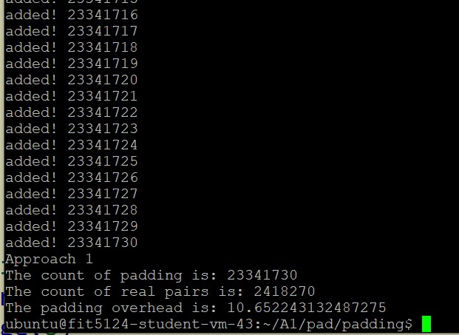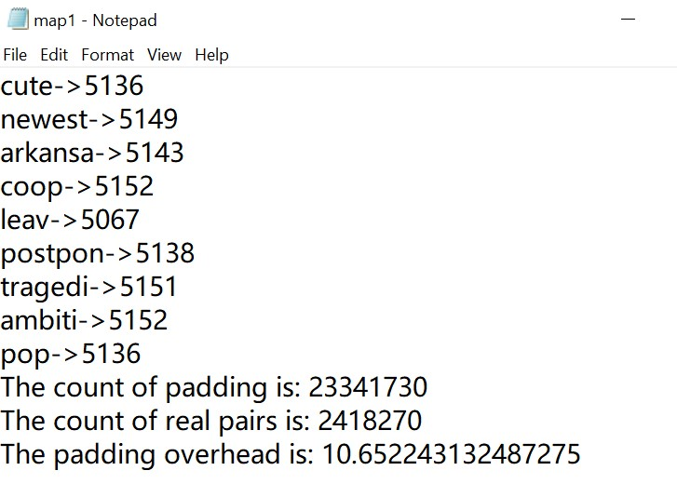
Fig 5.1.1 Fig 5.1.2
The overhead is ~10.65.
5.2 Approach #2
Source code:
The padding solution is to pad the id list of each keyword whose length is not a multiplication of 100 to the nearest multiplication of 100 larger than the original length.
Results:
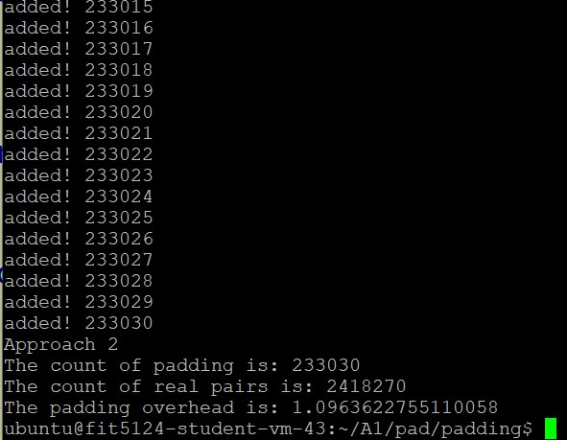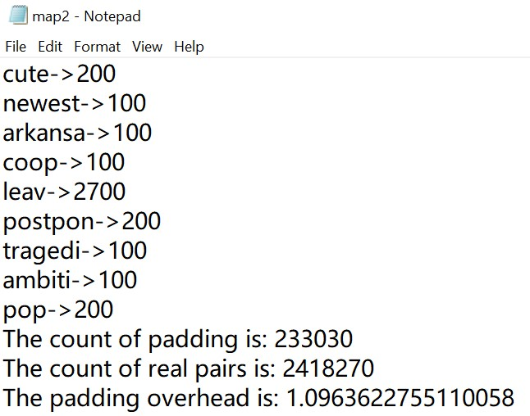
Fig 5.2.1 Fig 5.2.2
The overhead is ~1.10.
5.3 Approach #3
Source code:
This padding solution is to use a cluster to put the keywords having similar frequencies into one small group and inside the group, pad all keywords to the largest frequency.
Results:
App #3 – 256
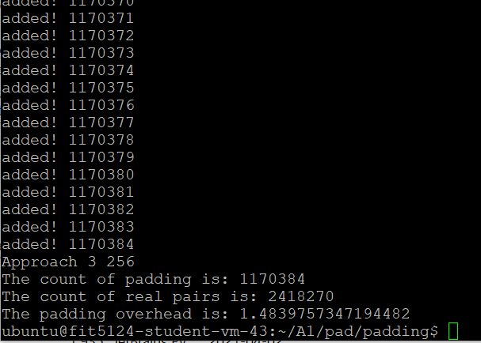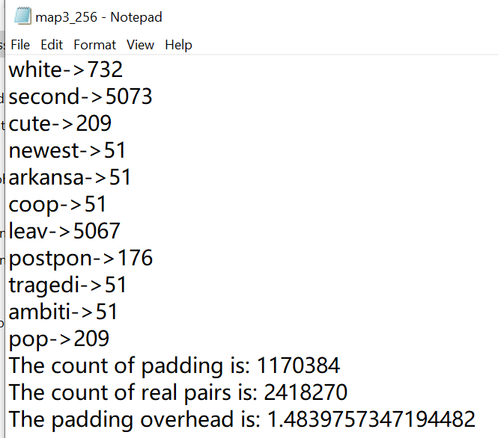
Fig 5.3.1 Fig 5.3.2
App #3 – 512
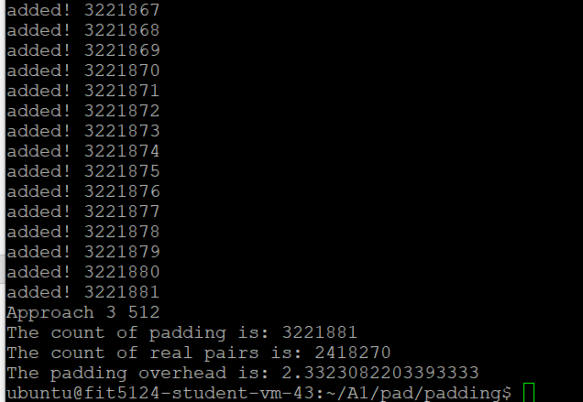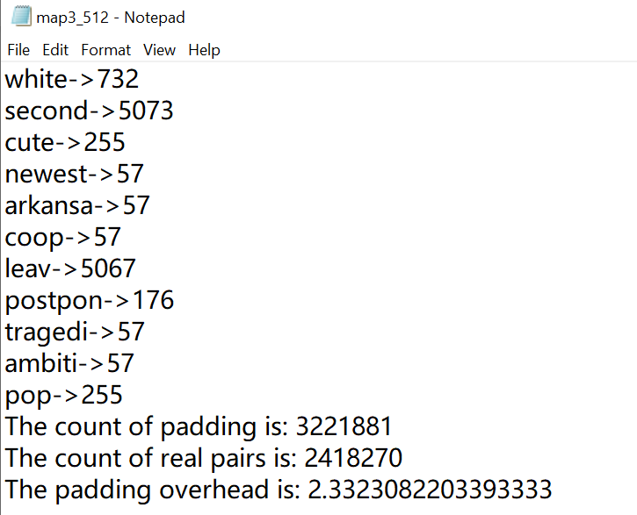
Fig 5.3.3 Fig 5.3.4
The overhead for cluster 256 is ~1.48, for cluster 512 is ~ 2.33.
5.4 Comparison
 | Approach #1 | Approach #2 | Approach #3 – 256 | Approach #3 – 512
Padding overhead | ~10.65224 | ~1.09636 | ~1.48398 | ~2.33231

The biggest overhead is approach #1, which is also called native padding.
App #2 has the smallest padding overhead, but we can see from the Fig 5.2.2: it’s very easy to guess that the padding pattern is multiplication of 100. Although we are not required to calculate the recovery ratio, we can observe the security strength of App #2 should be weaker than App #3.
Thus, under the same comparable security strength, the minimal padding will be App #3. We can also see that cluster 256 is smaller than cluster 512. This is because the smaller the cluster group is, the less padding will the approach need.
6 Inference Attacks against Order-preserving Encryption
Source code:
Results:
enc_age,raw_age
0->0
1->1
11->2
18->3
22->4
39->5
46->6
52->7
56->8
62->9
63->10
69->11
73->12
77->13
79->14
93->15
95->16
100->17
102->18
104->19
107->20
117->21
120->22
141->23
149->24
150->25
153->26
159->27
162->28
163->29
168->30
172->31
186->32
191->33
193->34
206->35
207->36
208->37
209->38
211->39
212->40
217->41
226->42
230->43
232->44
238->45
255->46
259->47
263->48
264->49
270->50
271->51
275->52
276->53
277->54
278->55
284->56
286->57
293->58
295->59
297->60
300->61
310->62
313->63
315->64
317->65
327->66
332->67
337->68
339->69
345->70
353->71
356->72
357->73
359->74
365->75
369->76
378->77
383->78
387->79
394->80
402->81
407->82
409->83
410->84
414->85
424->86
428->87
430->88
431->89
432->90
434->91
438->92
447->93
459->94
466->95
468->96
To check this result, I sorted the 2 .csv files in ascending order in Excel and observe the matches. It’s evident that this result is correct.

